
LinkedIn Influence Lab
Industrial capstone report: AI-guided personal branding with ChatGPT and Taplio
SAMPLE DATA. This report was generated from a fictional person and illustrative figures so you can see the finished format. It is not a real result.

Document control
Project | LinkedIn Influence Lab (Phase 1, 6 weeks)
Project code | LIL-2025-P1
Document | Industrial Capstone Report
Prepared for | Riya Mehta (Sample), Senior Operations Analyst
Learning path | Working Professional
Version / date | 1.1 · 13 November 2026
Classification | Confidential: client use

Contents
1 | Executive summary | Results at a glance and the deliverables produced
2 | Project overview and client background | Purpose, outcomes, client needs and constraints
3 | Business problem and objectives | Why a guided workflow is needed and what it must deliver
4 | User paths | Professional, job seeker and thought leader compared, with benefits and setbacks
5 | Solution and AI-guided workflow | The loop from inputs to analytics and back
6 | Phases, dependencies and backups | What each phase does, needs and hands on
7 | Branding and content strategy | Pillars, formats and engagement strategy
8 | Prompt templates | Templates A, B and C and how they are used
9 | Results and analytics | Metrics, insights and the self-assessment scorecard
10 | Path-specific results | KPIs that matter for the selected path
11 | Ethics and bias | Authenticity, inclusive language and attribution
12 | Risks and mitigations | Four risks and how each is handled
13 | Technical architecture | Layers, plugins and storage
14 | Operations | Running, backing up and restoring
15 | Limitations and assumptions | What this system does not do
A-C | Appendices | Glossary, traceability to the brief, document approval

1. Executive summary
This capstone delivers a complete, reproducible personal-branding system for Riya Mehta (Sample). It combines AI-assisted ideation, a six-week content calendar, a Taplio scheduling queue and an analytics loop. The primary path is Working Professional; the two alternative paths are fully supported and compared in section 4.
44/100  Audit score | 21  Ideas | 18  Drafts | 18  Calendar slots | 15  Posts logged | 5.30%  Engagement

Deliverable | Result | Brief requirement
Branding audit | 44/100 (Needs work); 7 gaps with fixes | Branding audit report
Content ideas | 21 generated | 15 or more
Post drafts | 18; average quality 91/100 | 10 or more optimized drafts
Content calendar | 18 slots over six weeks | Six-week calendar
Engagement dashboard | 15 posts, 5.30% engagement | Weekly dashboard
Performance review | Generated with recommendations | Performance review report

2. Project overview and client background
Purpose: help professionals build a strong personal brand on LinkedIn by combining Taplio's content workflow with ChatGPT-driven ideation and optimization.

Outcomes
- A consistent content strategy aligned with career goals
- AI-assisted content creation that increases visibility
- Engagement monitoring that informs the next cycle
- A reproducible framework for a sustainable personal brand

Client needs and constraints
- Needs: professional visibility, a consistent content pipeline, and a scalable system for ideation, scheduling and analytics.
- Constraints: Taplio free-tier limits, ChatGPT integration, and business-ready, reproducible deliverables.

3. Business problem and objectives
LinkedIn has more than a billion users, yet most professionals do not use it effectively for career growth. Typical causes are inconsistent posting, no content plan, and little time for engagement and analytics. This project answers with a structured, AI-guided lab that automates ideation, strategy alignment and performance monitoring.
- Build an AI-guided content ideation workflow
- Create a six-week content calendar with scheduling
- Draft optimized posts aligned with the personal brand
- Track engagement and derive actionable insights

4. User paths
Path | User story | Rhythm | Pillar mix | KPIs
Working Professional | I want a guided content workflow so that I can post consistently and grow my personal brand. | Tue, Wed, Thu | Career Insights 29%, Thought Leadership 24%, Industry Trends 24%, Actionable Tips 24% | Impressions, Comments, Profile visits
Job Seeker | I want to optimize my LinkedIn presence so that I attract recruiters and opportunities. | Mon, Wed, Fri | Actionable Tips 33%, Personal Journey 28%, Career Insights 22%, Industry Trends 17% | Profile visits, Recruiter messages, Connection requests
Thought Leader / Entrepreneur | I want to scale influence by using AI to generate impactful content aligned with my brand voice. | Tue, Thu, Sat | Thought Leadership 33%, Industry Trends 28%, Actionable Tips 22%, Personal Journey 17% | Followers gained, Shares, Inbound leads

Benefits and setbacks of the selected path (Working Professional)
Benefits | Setbacks
Steady credibility inside your niche with a balanced mix of five pillars. | Results are slower and broader: no single outcome (jobs, leads) is optimised.
Low-pressure rhythm (Tue/Wed/Thu) that is easy to keep for six weeks. | A balanced mix can feel generic unless you add real examples.
Peer engagement habit builds a network that compounds over time. | Needs six or more weeks of consistency before the trend is visible.
Works for any career stage, so it is a safe default.

5. Solution and AI-guided workflow
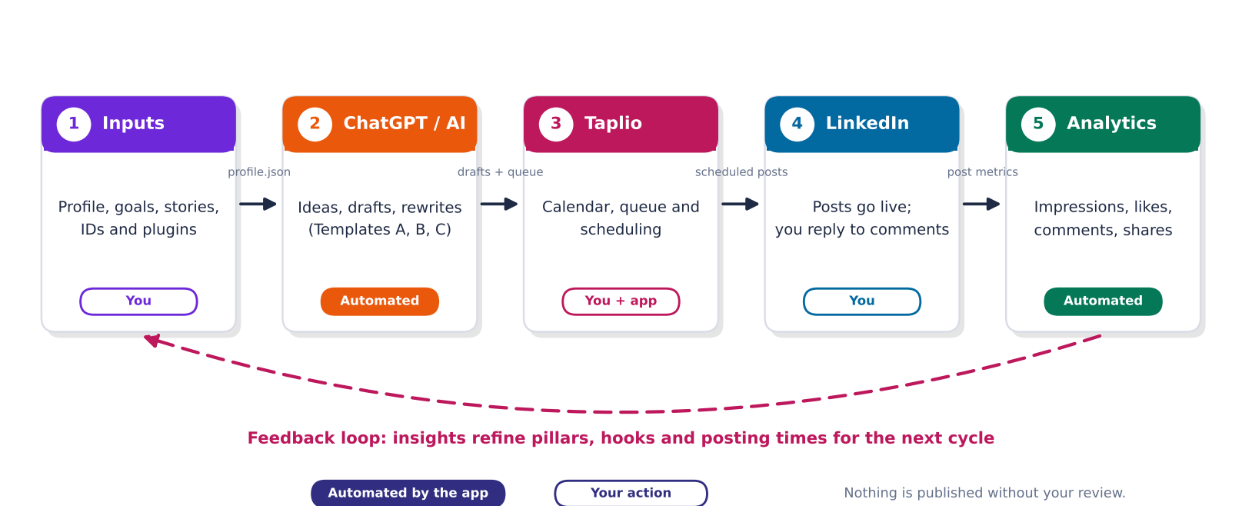
Figure 1. The AI-guided loop: inputs, AI, Taplio, LinkedIn, analytics, back to inputs
Inputs feed the AI plugin, whose drafts the author reviews. Approved posts go to Taplio and are published on LinkedIn; their metrics return as analytics that refine the next cycle's inputs. The pipeline automates everything except the steps that must stay human: reviewing, publishing and reporting real numbers.

6. Phases, dependencies and backups
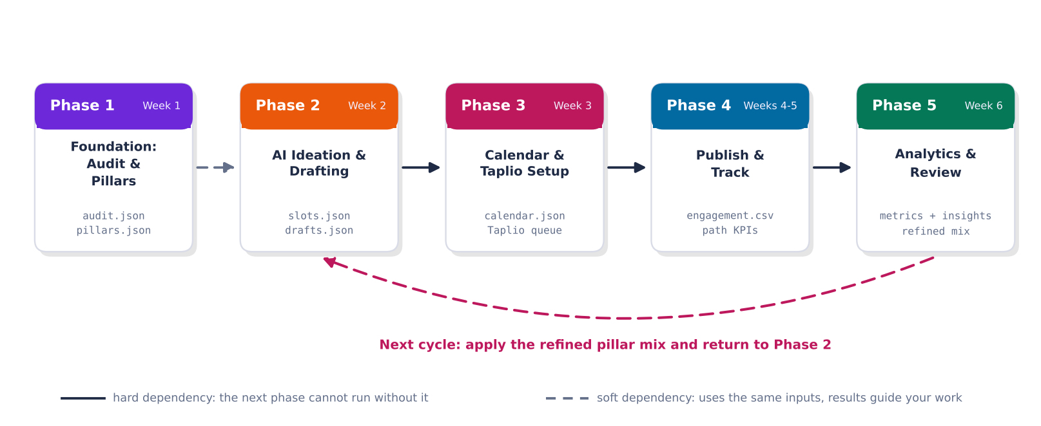
Figure 2. Phase dependencies: solid arrows are hard requirements, dashed are soft
Phase | When | What it does | Depends on | Produces
1. Foundation: Audit & Pillars | Week 1 | Scores your LinkedIn profile on a 12-point checklist (photo, banner, headline, About, Featured, skills, recommendations, numbers, visibility, cadence, network). | None. This is the starting point. | audit.json, pillars.json, personas.json
2. AI Ideation & Drafting | Week 2 | Builds the 6-week slot plan: date, pillar and format for every post (first 3 slots are the pilot). | Soft: reads your inputs, not Phase 1's files. Run Phase 1 first so you know which profile gaps to close. | slots.json, ideas.json, drafts.json
3. Calendar & Taplio Setup | Week 3 | Merges slots and drafts into the 6-week calendar (.xlsx, .csv, Sheets CSV). | Hard: stops with a clear message if Phase 2 has not run. | calendar.json, deliverables/01_content_calendar/*, deliverables/06_taplio_queue/*
4. Publish & Track | Weeks 4-5 | Prepares tracking: marks calendar posts as Published when you log them. | Hard: needs calendar.json from Phase 3. | engagement.csv, persona_kpis.csv
5. Analytics & Review | Week 6 | Computes weekly trends and breakdowns by pillar, format and weekday. | Hard: with no logged engagement it explains what is missing instead of inventing numbers. | metrics_summary.json, insights.json, scorecard.json

Every phase run saves a checksummed zip backup; a full snapshot is created after the automated pipeline.

7. Branding and content strategy
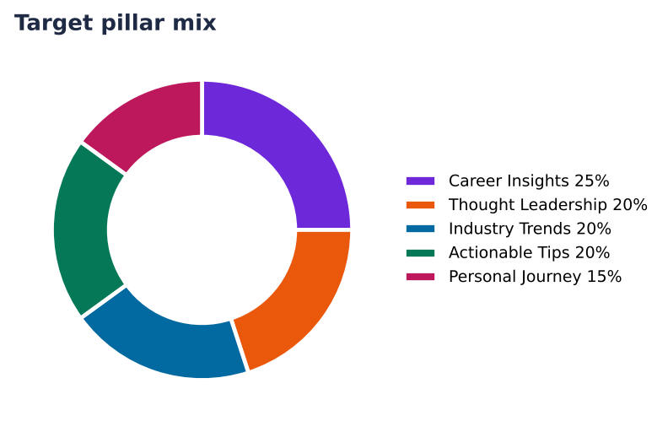
Figure 3. Target pillar mix
Pillar | Share | Posts | What it covers
Career Insights | 25% | 4 | Hard-won lessons about growth, promotions and decisions.
Thought Leadership | 20% | 4 | Opinions, frameworks and bets that make people think.
Industry Trends | 20% | 4 | What is changing in your field, explained in plain English.
Actionable Tips | 20% | 4 | Checklists, templates and habits people can use today.
Personal Journey | 15% | 3 | Honest stories: wins, mistakes and what you are learning.

Formats: text posts, carousels (built as a PDF in a design tool), polls and micro-stories. Engagement strategy: reply to every comment within two hours, comment on five peers' posts daily, and share curated content with its source.

8. Prompt templates
Template | Prompt | Used for
A | Generate 5 engaging LinkedIn post ideas about [industry/career topic]. | Phase 2 ideation
B | Rewrite this draft in a professional but relatable tone. | Rewrite tone button on each draft
C | Summarize this article into a LinkedIn post with 3 key takeaways. | Template C tool; always credits the source

9. Results and analytics
SAMPLE DATA The figures below are illustrative sample data.

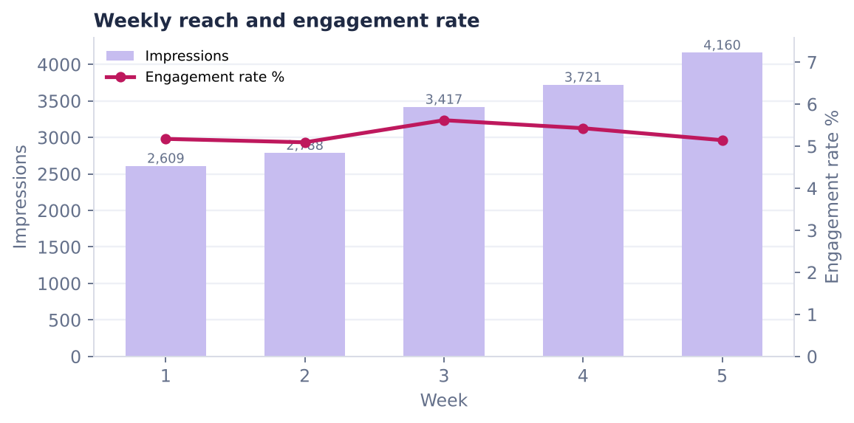
Figure 4. Weekly reach and engagement rate
What we saw | What to do next
'Thought Leadership' is your strongest pillar (5.8% engagement). | Raise its share of the next calendar by about 10 points; keep the others for range.
Poll posts perform best (5.9%). | Use this format at least twice a week; test a new hook style inside it.
Tuesday posts lead on engagement. | Move one more post to Tuesday (same time of day) and compare.
Engagement rate is down 1% from first to latest week. | Review the latest week's hooks against the first week's winners.
2.1% of impressions became profile visits. | Make sure the headline and Featured section convert those visits (see the audit).
64 peer comments made across 5 logged week(s). | Keep the 5-comments-a-day habit; consistent peer visibility is what lifts reach over time.

Criterion | Weight | Score
Content Quality & Relevance | 30% | 91.3
Consistency of Posting | 25% | 100.0
Engagement Growth | 20% | 49.7
Personal Branding Alignment | 15% | 93.9
Documentation & Clarity | 10% | 100.0
Overall |  | 86.4

10. Path-specific results
Working Professional KPI | Logged | Six-week target | Progress
Profile visits (week) | 140 | 150 | 93%
Peer comments you made | 64 | 70 | 91%
New relevant connections | 35 | 40 | 88%

11. Ethics and bias
- Avoid over-automation: nothing is queued as approved until the author ticks Human reviewed.
- Inclusive and neutral language: the quality checker flags non-inclusive terms and suggests replacements.
- Attribute sources: statistics or studies without a named source are flagged; Template C always adds a Source line.

12. Risks and mitigations
Risk | Mitigation (brief) | Implemented as
Low engagement | Adjust posting time and content type | The insights flag a rate below 2% and suggest hook, format and time tests.
Free-tier limits in Taplio | Supplement with manual LinkedIn analytics | Manual entry and a flexible CSV importer for LinkedIn or Taplio exports.
Over-reliance on AI | Ensure human review for authenticity | A Human reviewed gate on every draft; only approved posts enter the approved-only Taplio queue.
Consistency drop-off | Use scheduling to avoid gaps | Taplio queue, .ics reminders, and a consistency score and streak on the dashboard.

13. Technical architecture
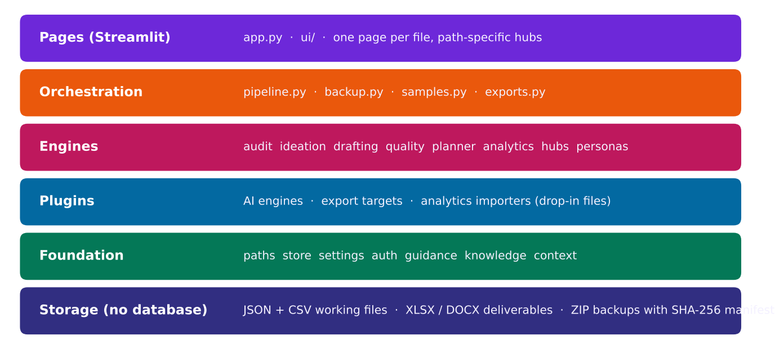
Figure 5. Layered architecture; no database, only files
Python 3.10+, Streamlit, pandas, openpyxl, python-docx, matplotlib, plotly and requests. Plugins (AI, export, import) are drop-in files. All folders are resolved by one module, and the sample workspace is physically separate from the user's own workspace.

14. Operations
- Run: run_app.bat (Windows) or run_app.sh; open the local address shown.
- Back up: every phase run and the pipeline create zip backups with a SHA-256 manifest in backups/.
- Restore: verify, take a safety snapshot of the current state, clear the covered folders, extract.
- Details: HOW_TO_RUN.txt and docs/07_BACKUP_AND_RESTORE.md.

15. Limitations and assumptions
- Publishing on LinkedIn and scheduling in Taplio remain manual by design.
- Drafts from the built-in engine are first drafts; they depend on the author's real examples.
- AI plugins require the user's own API key; they were validated with mocked responses.
- Taplio plan limits vary; manual entry and CSV import cover analytics gaps.

Appendix A. Glossary
Term | Meaning
Pillar | One of 3-5 recurring topics a profile posts about.
Hook | The first line of a post; it decides whether readers open 'see more'.
Engagement rate | (Likes + comments + shares) divided by impressions.
Pilot | The first 2-3 posts, used to test formats before the full run.
Human reviewed | The author's confirmation that a draft was read, edited and approved.
Taplio queue | The CSV and copy-paste pack used to schedule posts in Taplio.
Plugin | A drop-in file that adds an AI engine, an export target or an importer.
Workspace | A self-contained set of data folders: your own, or the sample one.

Appendix B. Traceability to the project brief
# | Brief section | How it is covered
1 | Project Overview | Purpose and outcomes are the top of the README and the Command Center hero.
2 | Client Background | Needs and constraints captured as inputs and requirements (Taplio free tier, ChatGPT, reproducible).
3 | Business Problem Statement | The AI-guided workflow: ChatGPT/AI > Taplio > LinkedIn > analytics > inputs, automated by one pipeline.
4 | User Story | All three paths (professional, job seeker, thought leader) change pillars, cadence, CTAs and KPIs.
5 | Acceptance Criteria | Live tracker: 15+ ideas, 10+ posts, metrics per post, 6-week calendar, review report.
6 | Project Objectives | Ideation workflow, calendar, optimized drafts, engagement insights map to phases 2, 3, 2, 5.
7 | Project Tasks (Phase 1) | Seven tasks implemented as five phases with a backup after each.
8 | Deliverables | Calendar, drafts, dashboard, audit report, performance report (+ capstone report, Taplio queue).
9 | Technical Requirements | Web-based Python app, no extra installs beyond pip packages; Taplio/ChatGPT/Sheets supported.
10 | Input Information | Profile, audience/industry, role models, plus your IDs, stories and plugin keys.
11 | Evaluation Criteria | Self-scorecard with the exact 30/25/20/15/10 weights.
12 | Getting Started | HOW_TO_RUN.txt and the beginner guide; first-run checklist in the Command Center.
13 | Support | Troubleshooting FAQ with the response-time targets (1 day / 2-3 days / weekly).
14 | Solution Overview | Pipeline: ideas > drafts > scheduling, engagement monitoring, iterative refinement.
15 | Technical Approach | Ideation, scheduling queue, analytics, and the feedback loop (refined pillar mix).
16 | Branding & Content Strategy | 5 pillars, 4 formats, engagement strategy in the capstone report.
17 | AI-Guided Workflow | Templates A, B, C wired to AI plugins with offline fallbacks.
18 | Analytics & Reporting | Metrics, weekly dashboard, monthly-style performance report.
19 | Bias & Ethical Considerations | Human-review gate, inclusive-language check, source attribution check.
20 | Technical Documentation for End Users | Step-by-step guide, prompt templates, example calendar, FAQ.
21 | Quality & Acceptance Criteria | Automated tests plus the Command Center acceptance tracker.
22 | Project Plan & Timeline | Phase catalogue mirrors the Week 1-6 plan.
23 | Risks & Mitigations | Four risks, each with a built-in mitigation and an insight rule.
24 | Appendices | Prompt templates, calendar sample, tracking sheet, profile checklist.

Appendix C. Document approval
Role | Name | Signature | Date
Prepared by
Reviewed by
Approved by

